Kaggle Raw dataset Link :
https://www.kaggle.com/datasets/roopacalistus/superstore

Cleaned Dataset Excel file :
https://drive.google.com/drive/folders/1mU_yYQcuU1upmTzfo_HoZXoO-0MeA6m8?hl=en

Power BI PDF –
https://drive.google.com/drive/folders/1mU_yYQcuU1upmTzfo_HoZXoO-0MeA6m8?hl=en

Sample SuperStore:
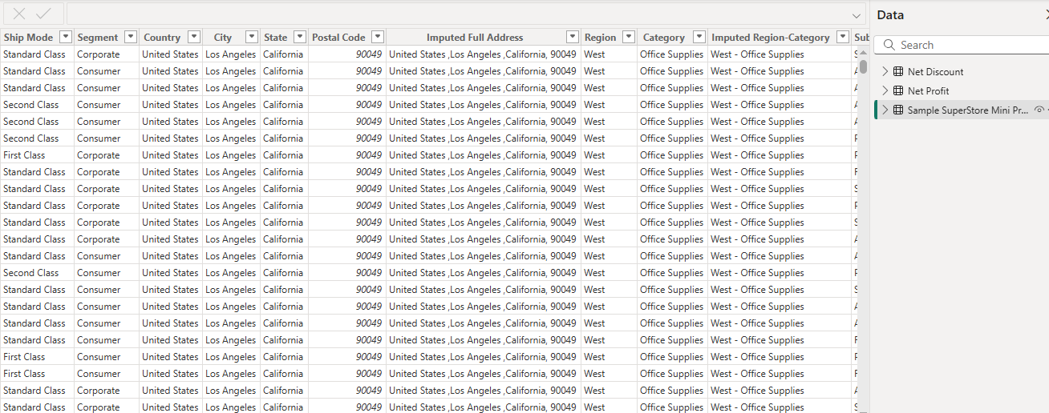
Net Profit:
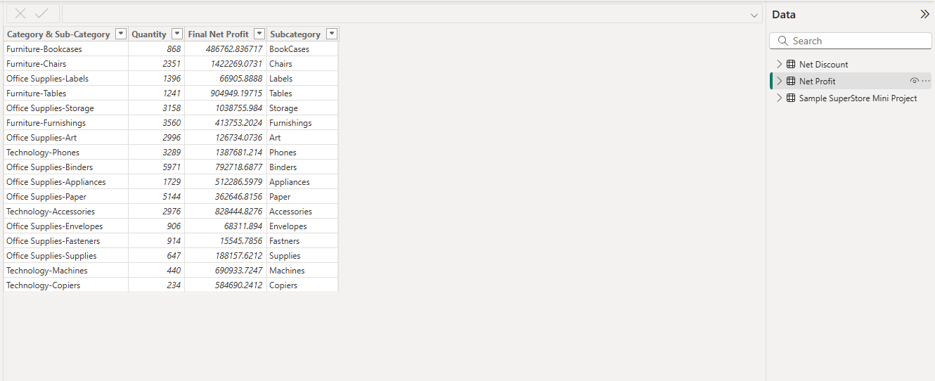
Net Discount: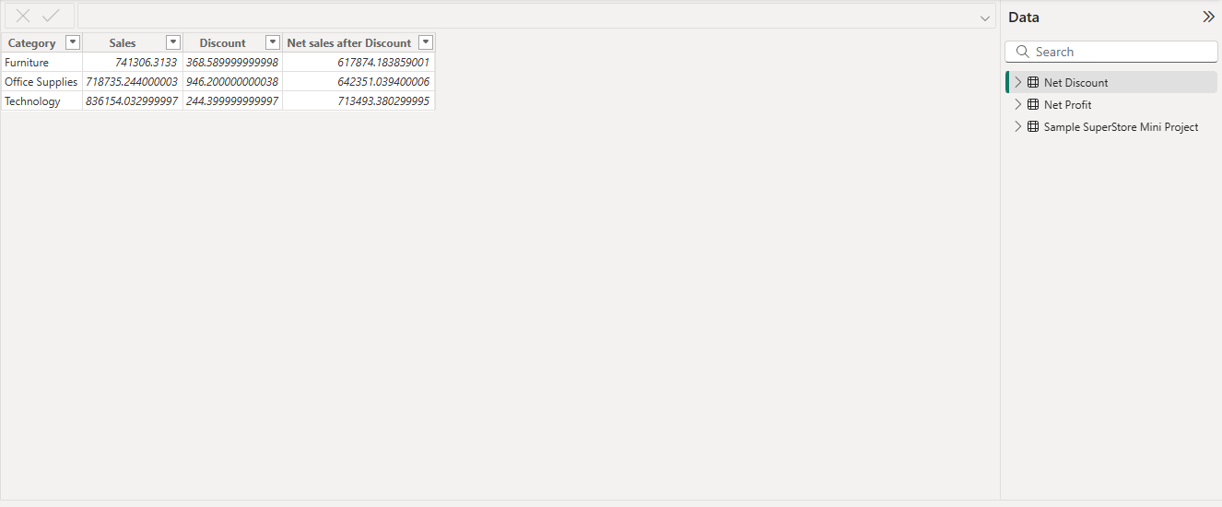
Sanmple SuperStore Model View 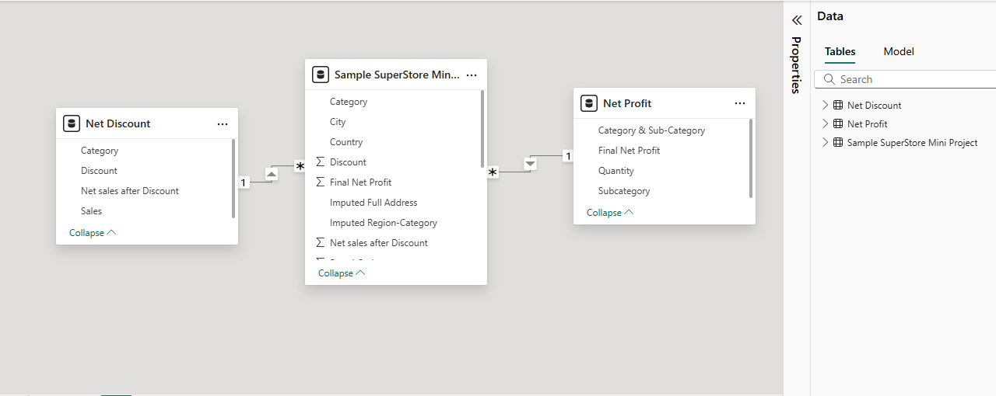
Sample SuperStore Dashboard: